News on PLCnext Technology (plcnext-community.net)
Friday, February 26, 2:10pm-3pm (UTC-8:00)
https://connect.isa.org/HigherLogic/System/DownloadDocumentFile.ashx?DocumentFileKey=92f3944e-584e-f472-6e0d-4b7b980fa783&forceDialog=0
Intro_to_Programming_PLCnext_IEC611-31

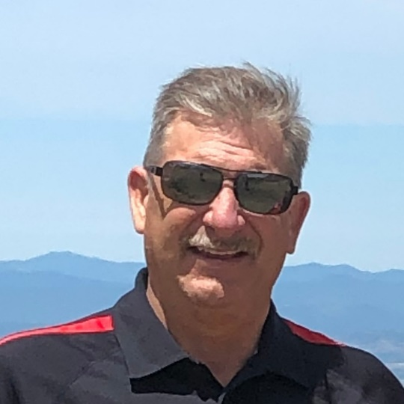 | 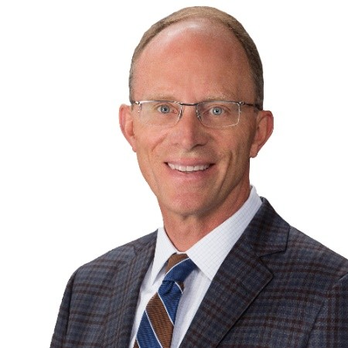
Mark Dean; Phoenix Contact, Project Sales Engineer; Walnut Creek, California | Dave Eifert; Phoenix Contact USA; Vertical Market Manager - Water/Wastewater Bay Village, Ohio, United States

Read more about PLCNext & the Open Process Automation Forum:
ExxonMobil and PLCnext for New Open Process Automation - YouTube
Read more about PLCNext:
PLCnext - Connecting Industrial Automation to the IT World - YouTube

